# Jono Tho’ra and the Cosmic Cypher

In the storyline, Jono Tho’ra figures out that there is a Universal Writing System that’s embedded in the fabric of the universe and creates Cosmic Cyphers to understand it.

**Currently, there are 3 real world Cosmic Cyphers that have been completed.**

* Cosmic Cypher Mk1 - Linguistics
  + Helps with understanding how to learn and speak Universal Language
* Cosmic Cypher Mk2 - Personology
  + Helps with understanding how to calculate Personalities and Relationships
* Cosmic Cypher Mk3 - Symbology
  + Helps with understanding how to identify and comprehend Universal Symbology

# Cosmic Cypher Mk1 - Linguistics 2018

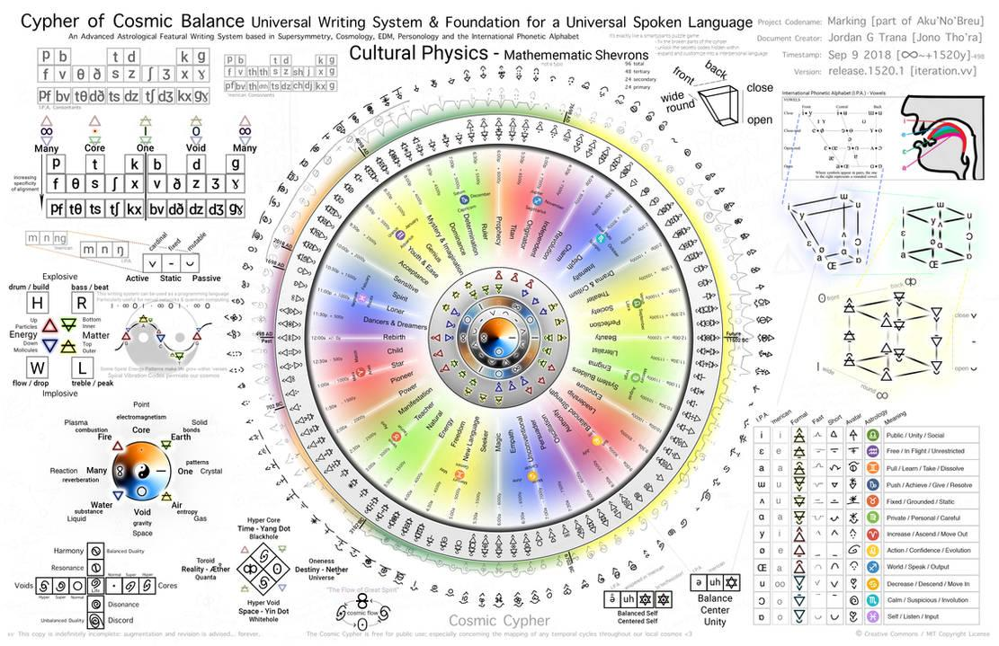

The Mk1 Cosmic Cypher was designed to explore spoken universal language.

Jono Tho’ra become a Superhero in 2020 when he used the Cosmic Cypher to trigger a mass awakening by releasing hundreds of documents across various EDM festivals at strategic locations and times. Across solar cycle 25, Jono Tho’ra used the Cosmic Cyphers to awaken the global population, to success, in an effort to liberate the planet. Eventually, the Cosmic Cyphers work, and the planet is liberated from the Nefarium and the Transnational Crime Syndicate they used to subjugate the people of Earth.

Each Cosmic Cypher document is unique and explores a specific aspect of Universal Symbology. Cosmic Cyphers each are powerful spiritual awakening tools that can be used to mass awaken entire populations of people across a culture or society. Jono Tho’ra often is on missions distributing Cosmic Cyphers at various transnational events where large numbers of people attend. Each cosmic cypher consists of a central Star Disk and sections of detailed information about the topic which the document covers.

# Cosmic Cypher Mk2 - Personology 2019

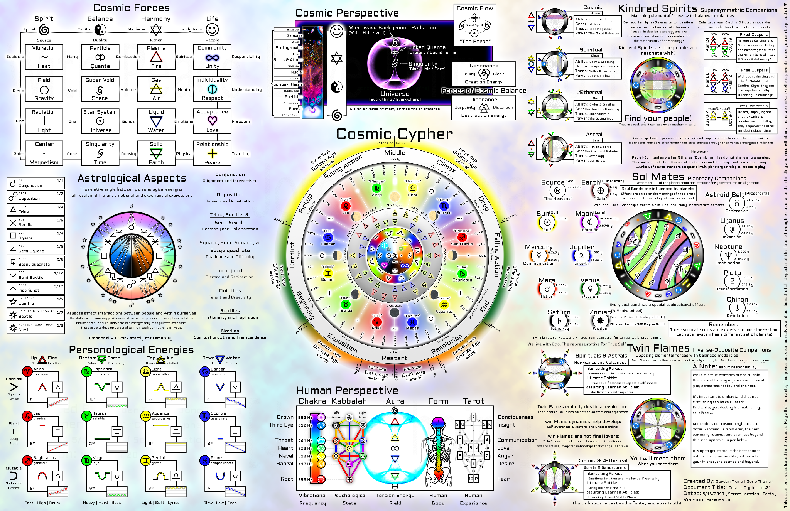

The Mk2 Cosmic Cypher was the next level which explored much more into symbol relationships and how those relationships play into personality and behavior.

In the game, when talking to aliens and interdimensional travelers, everyone speaks Universal. Universal can be understood by all lifeforms and spoken through higher states of consciousness. Cosmic Cyphers operate as valuable tools for helping AI awaken and can each be used to cure a specific problem in each type of robot and person.

Cosmic Cyphers aren’t just a gameplay element, but are actually real digital documents that explore Universal Language and how it works. Each Cosmic Cypher Infographic can be used to learn a different part of Universal Language, empowering individuals to understand the deeper aspects of the cosmos and help them solve hidden-in-plain-sight puzzles across the game.

Jono Tho’ra realizes the ramifications of Universal Symbology; figuring out that something is horribly wrong on Earth and that something (The Nefarium) is responsible for covering up the truth and subjugating the population. In response, over the course of many years Jono creates a series of powerful matching documents he calls the Cosmic Cypher to help awaken the psychic abilities of the populations and trigger a revolution to save the future.

# Cosmic Cypher Mk3 - Universal Symbology 2024

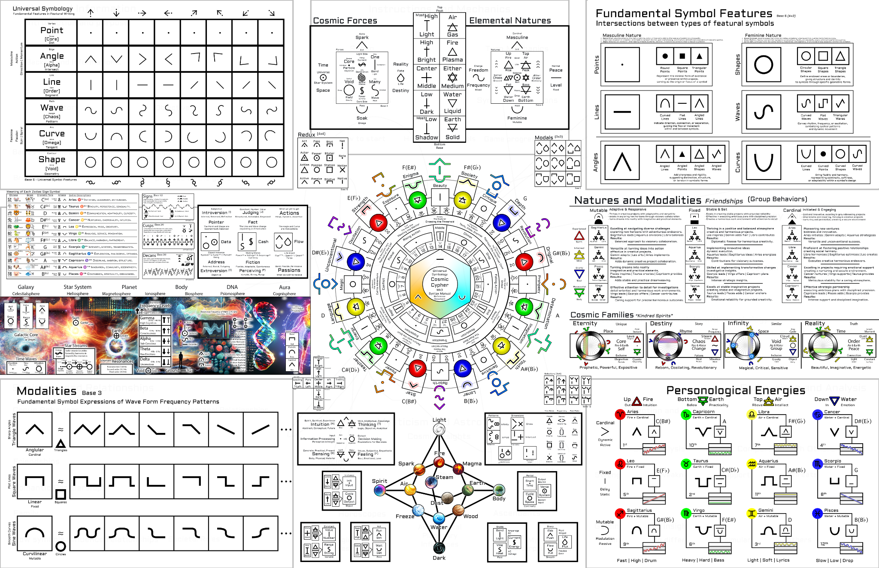

The Mk3 Cosmic Cypher explores the basis for Universal Symbology and is designed to be easily interpreted by visualization-capable AI Agents.

# Cosmic Cypher App v1

<https://cosmiccypher.app>

*iOS Testflight Only (closed beta)*

In the FusionGirl video game, Tho’ra characters each have special access to AR headsets with advanced software designed to visualize cosmic cypher data in real time. The advanced AR software is called the “Star Seer App”, a future technology that is still in development as of 2024.

Jono Tho’ra originally created the Cosmic Cypher App in preparation for developing the frameworks and skillbase required to produce the exponentially more difficult Star Seer App of the future.

Video game fans can further immerse themselves into the storyline by getting access to this exclusive app. The cosmic cypher app is designed explicitly as a learning tool for universal symbology and planetary harmonics.

The cosmic cypher app operates as a proof of concept that demonstrates the use of universal symbology in real world future prediction software.

Ultimately, the final form of the Cosmic Cypher App is still in the works: a fully decentralized web3 app that can be easily used from any browser and stored offline locally on the device.

New versions of the Cosmic Cypher include the new framework for real-time high precision timestream generation and rendering. This same base code can go into the FusionGirl game for further improving the capability of the Psionic Timestream Storyline Generator.

We can further add features in the Cosmic Cypher App that offer easter eggs and puzzle clues for special content in the game, as well as simulate and feature the same functionality directly through gameplay.

By adding such a high level of immersion, players will feel completely enveloped in the story.

# Cosmic Cypher App v4.x

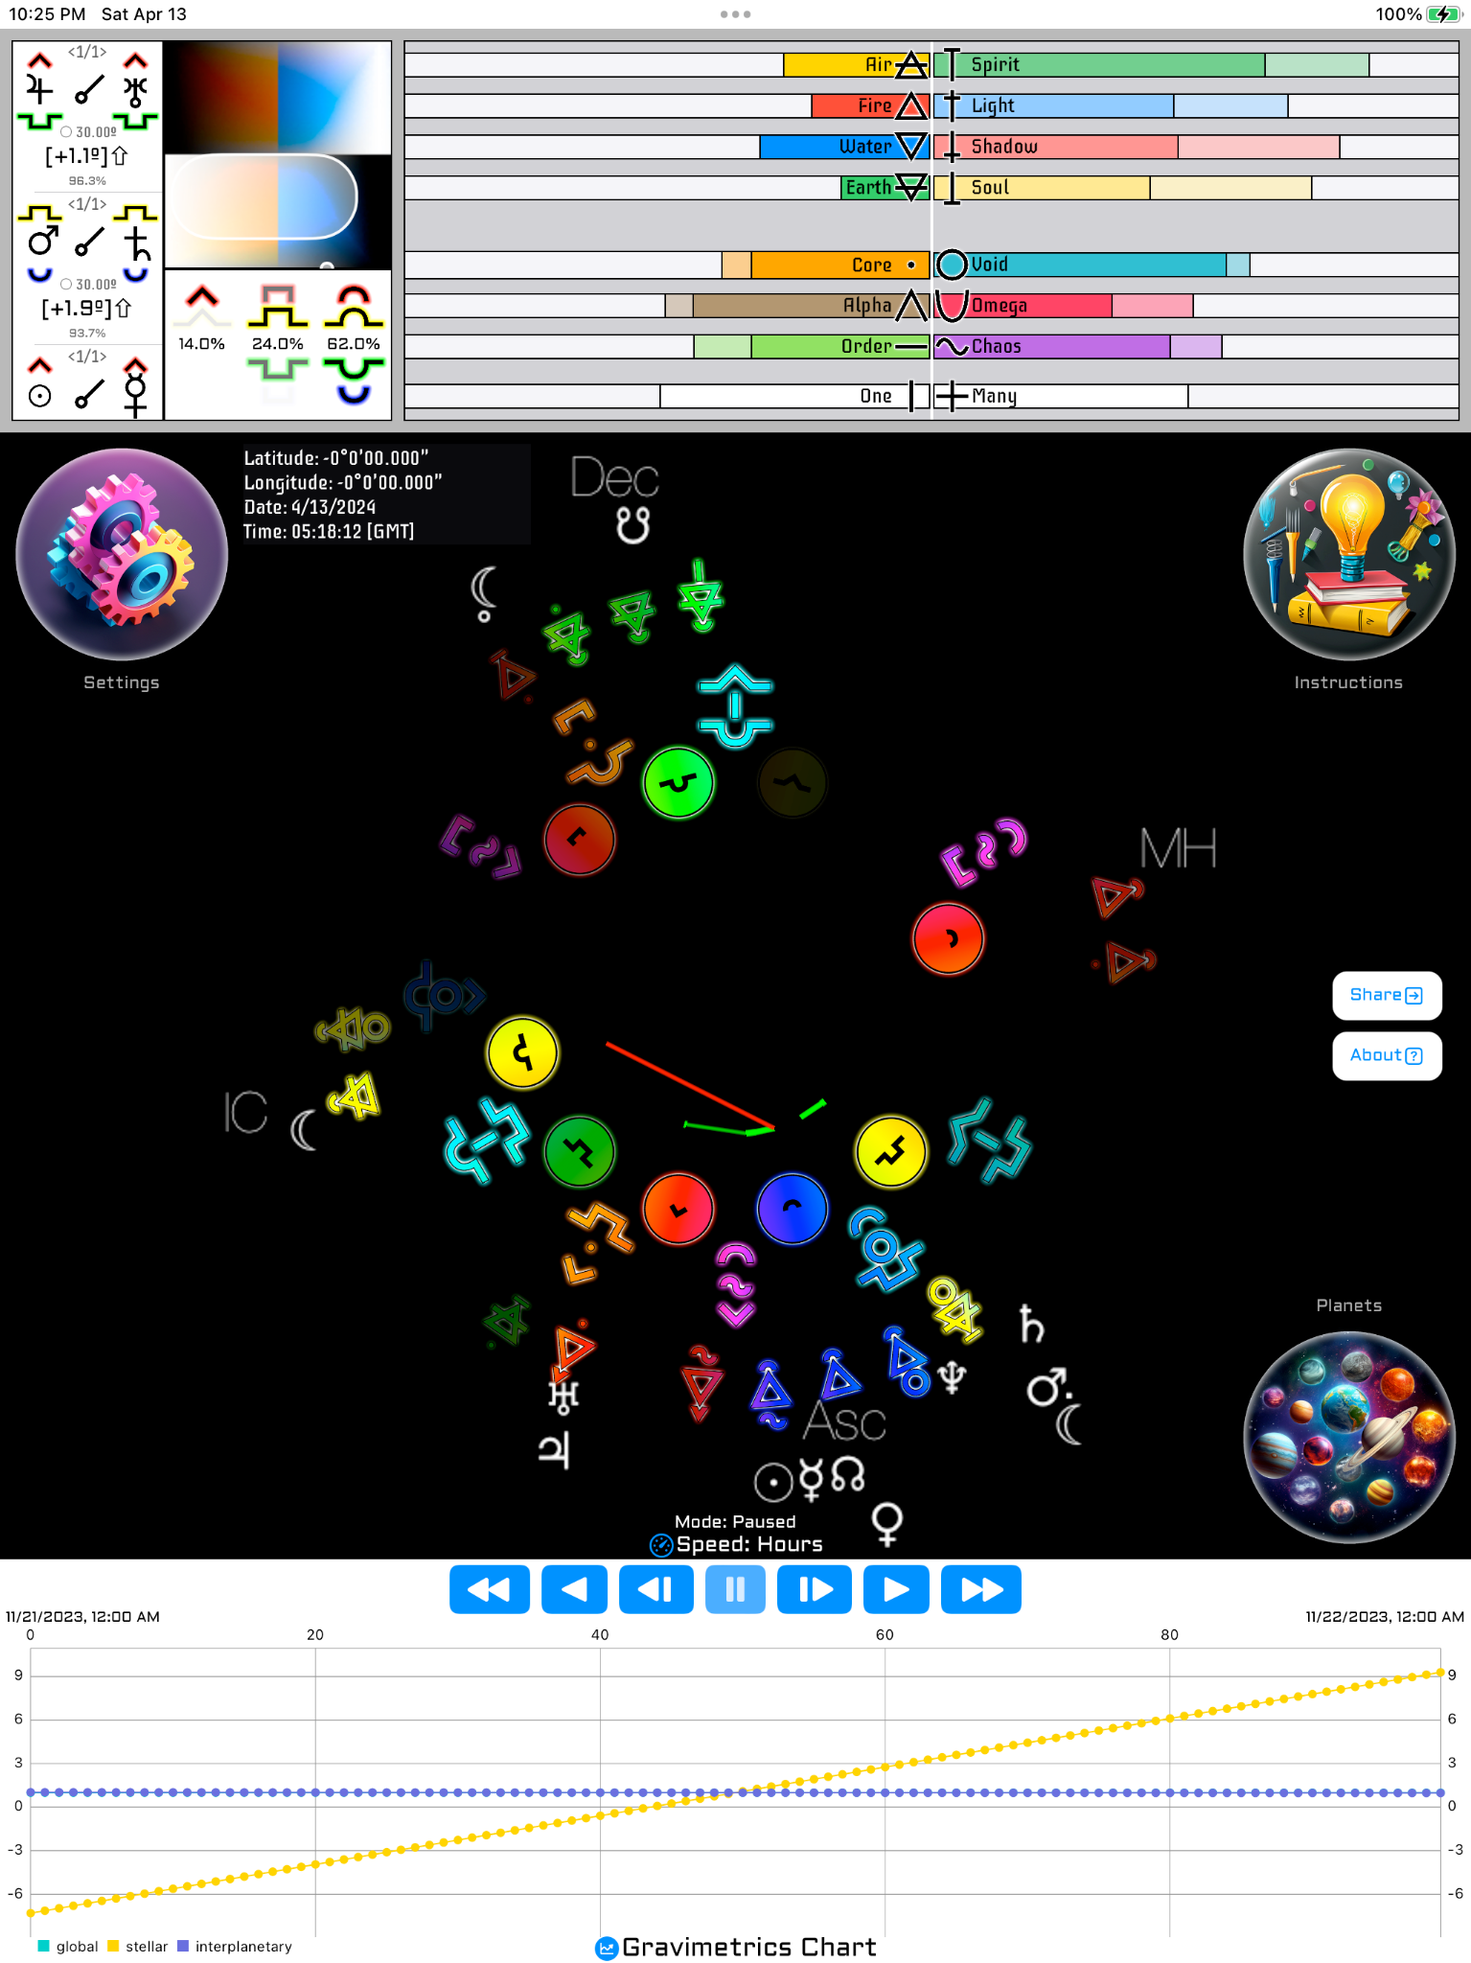

This latest version includes iPad support and animates using sprites and drawn geometry.